Taming Column Widths in SolidWorks BOMs
(Information supplied by Tor Iveroth)
Have you viewed a SolidWorks BOM in the BOM tab of Windows Explorer and noticed that your column widths are too big?
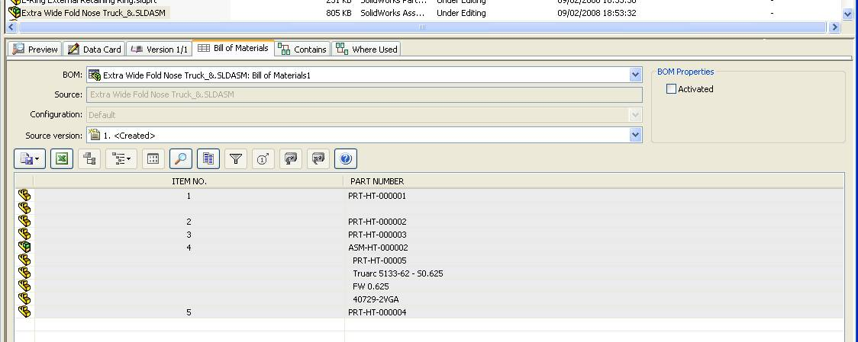
This is controlled by the option ‘BOM Scaling’:
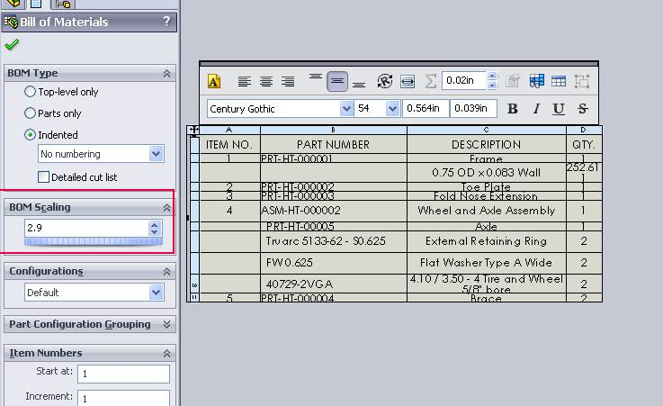

If you ‘dial down’ the BOM Scaling value:
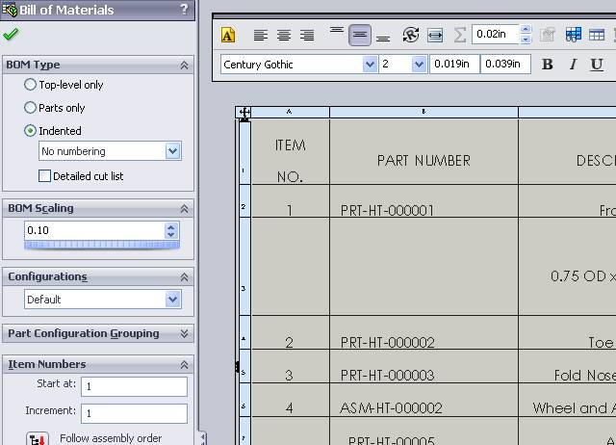
You will tame your column widths:
